1/9/2022

Krishna Kumar

[company name]

AZ204 Lab 2

Server less

Index

Exercise 1: Create Azure resources

### Exercise 2: Configure a local Azure Functions project

### Exercise 3: Create a function that’s triggered by an HTTP request

### Exercise 4: Create a function that triggers on a schedule

### Exercise 5: Create a function that integrates with other services

### Exercise 6: Deploy a local function project to an Azure Functions app

### Exercise 7: Clean up your subscription

### https://microsoftlearning.github.io/AZ-204-DevelopingSolutionsforMicrosoftAzure/Instructions/Labs/AZ-204_lab_02.html

Exercise 1: Create Azure resources

#### **Create an Azure Storage account**

Step-1

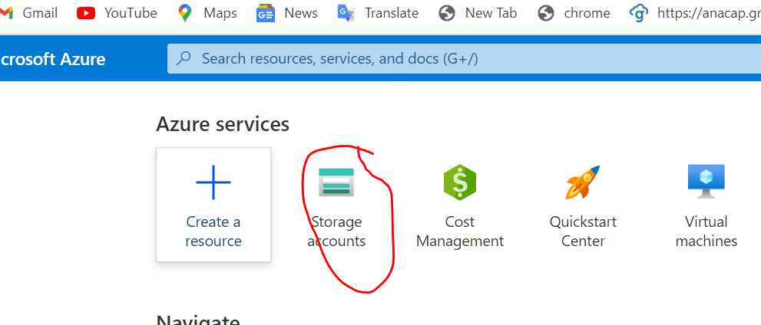

Step-2

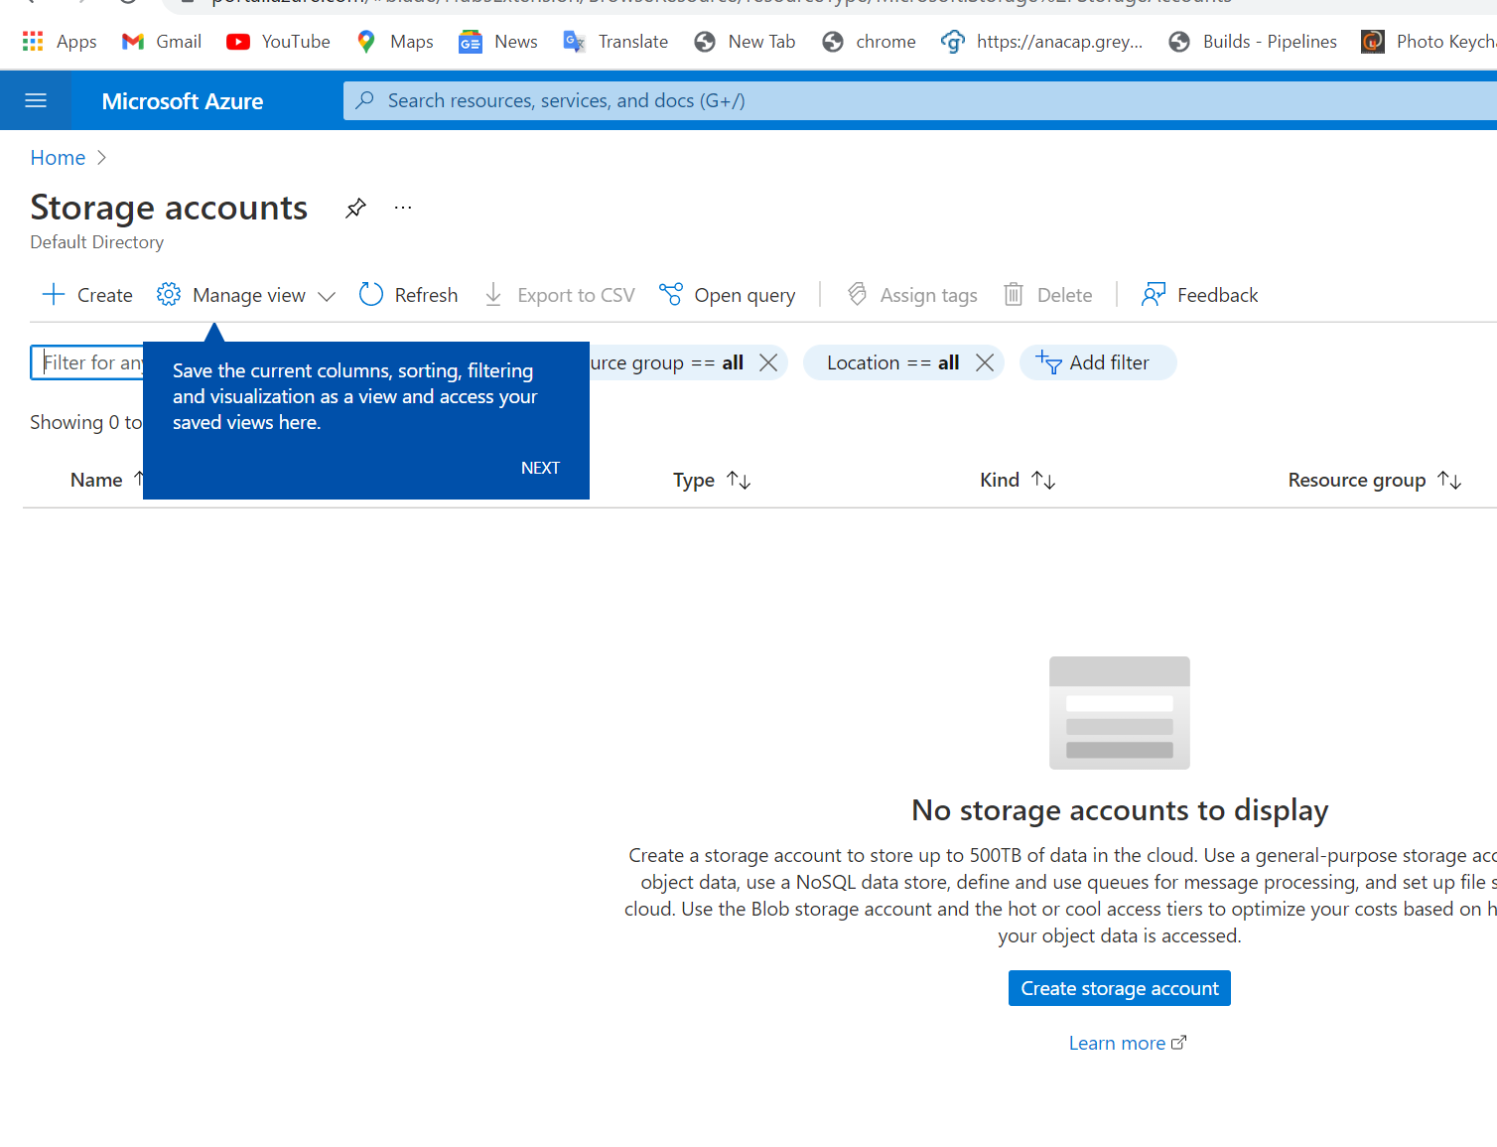

Step-3

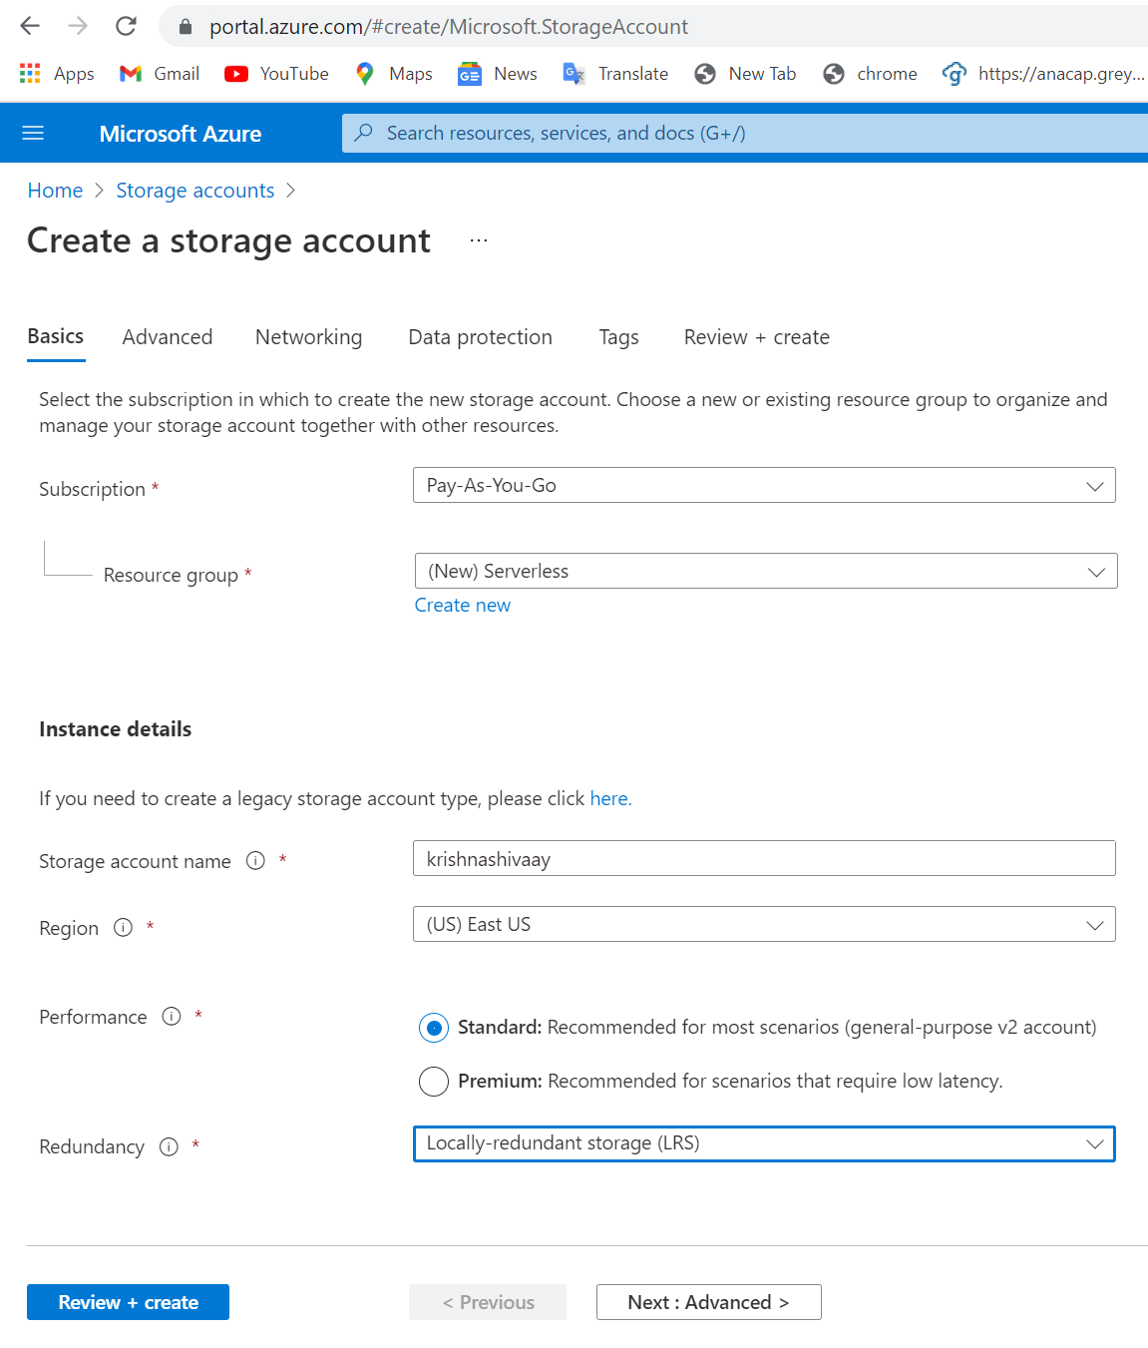

Step4

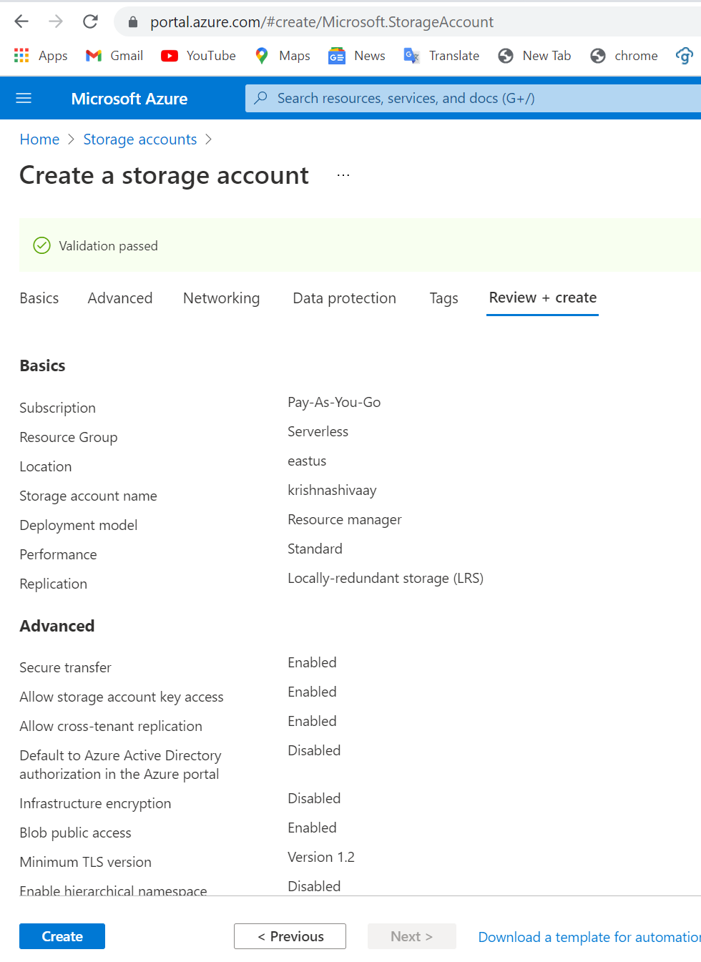

Step 5

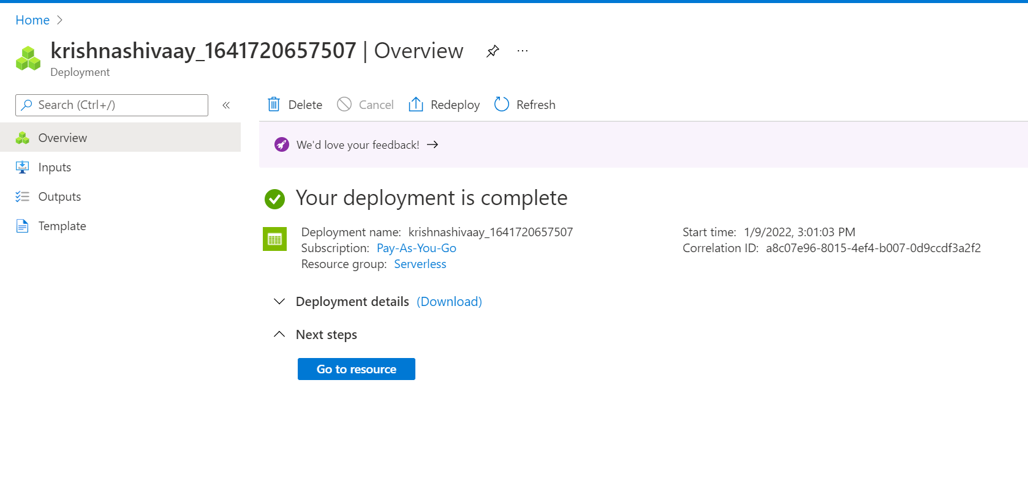

### Step 6

### 

#### **Task 3: Create a function app**

1.

### 

### 2.

### 

### 3.

### 

### 

### Exercise 2: Configure a local Azure Functions project

### 1.

### 

### 2.

### 

### 3.

### 

### 

#### **Task 2: Configure a connection string**

1. On the **Start** screen, select the **Visual Studio 2019** tile.
2. On the **File** menu, select **Open Folder**.
3. On the **Explorer** pane of the **Visual Studio 2019** window, open the **local.settings.json** file.
4. Observe the current value of the **AzureWebJobsStorage** setting:

### 

1. Update the value of the **AzureWebJobsStorage** by setting it to the **connection string** of the storage account that you recorded earlier in this lab.
2. Save the **local.settings.json** file.

### 

### Exercise 3: Create a function that’s triggered by an HTTP request

### 1.

### 

### 2.

### 

### 3.

### 

### Delete all the content within the Echo.cs file.

### Include the following code:

### 

1. Used Post man to call that Http Trigger azure function

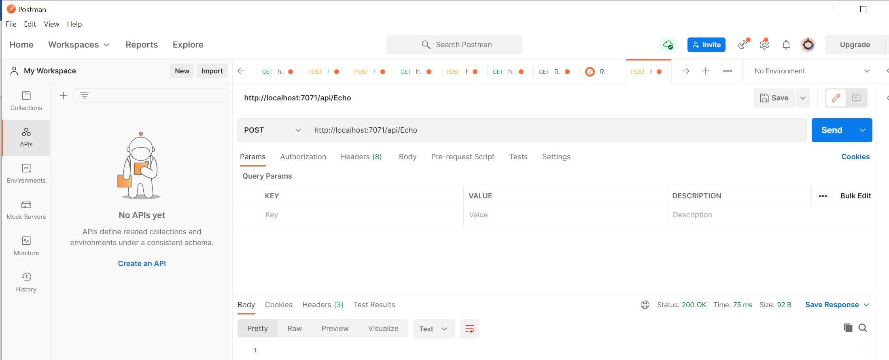

### 

#### **Review**

In this exercise, you created a basic function that echoes the content sent through an HTTP POST request.

### Exercise 4: Create a function that triggers on a schedule

#### **Task 1: Create a schedule-triggered function**

1.

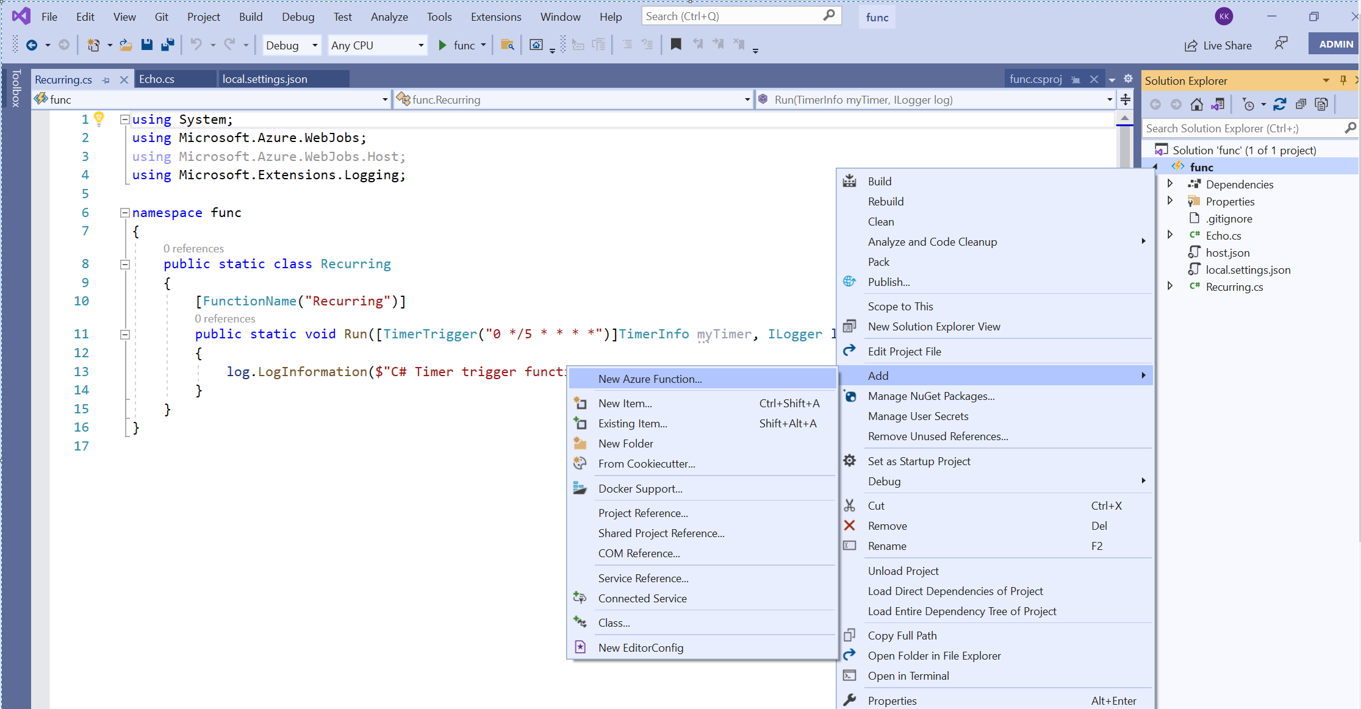

2.

### 

### 3.

### That schedule function will trigger in every 5 mins we can change time into here

### 

### Out put

### Exercise 5: Create a function that integrates with other services

#### **Task 1: Upload sample content to Azure Blob Storage**

1. On the Azure portal’s **navigation** pane, select the **Resource groups** link.
2. On the **Resource groups** blade, select the **Serverless** resource group that you created previously in this lab.
3. On the **Serverless** blade, select the **funcstor**[yourname] storage account that you created previously in this lab.
4. On the **Storage account** blade, select the **Containers** link in the **Data storage** section.
5. In the **Containers** section, select **+ Container**.
6. In the **New container** pop-up window, perform the following actions, and then select **Create**:

| Setting | Action |
| --- | --- |
| **Name** text box | Enter **content**. |
| **Public access level** drop-down list | Select **Private (no anonymous access)**. |

1. Return to the **Containers** section, and then select the recently created **content** container.
2. On the **Container** blade, select **Upload**.

### 

### 

### 

#### **Task 2: Create an HTTP-triggered function**

1.

### 

### 2.

### 

### 3.Delete all the content within the **GetSettingInfo.cs** file.

1. Add the following lines of code to add **using directives** for the **Microsoft.AspNetCore.Http**, **Microsoft.AspNetCore.Mvc**, and **Microsoft.Azure.WebJobs** namespaces:

C#Copy

using Microsoft.AspNetCore.Http;

using Microsoft.AspNetCore.Mvc;

using Microsoft.Azure.WebJobs;

### 

### 4. Test that function

### 

### 

### Output

### Nothing is returning…..

### 

### Exercise 6: Deploy a local function project to an Azure Functions app

### 1. task 1

### 2.

### .

#### **Task 2: Validate deployment**

1. On the taskbar, select the **Microsoft Edge** icon, and select the tab that contains the Azure portal ([https://portal.azure.com](https://portal.azure.com/)).
2. On the Azure portal’s **navigation** pane, select the **Resource groups** link.
3. On the **Resource groups** blade, select the **Serverless** resource group that you created previously in this lab.
4. On the **Serverless** blade, select the **funclogickrishnashivaay** function app that you created previously in this lab.
5. On the **App Service** blade, select the **Functions** option in the **Functions** section.

### 

### 

1. On the **Functions** pane, select the existing **Recurring**function. It is running in every 5mins

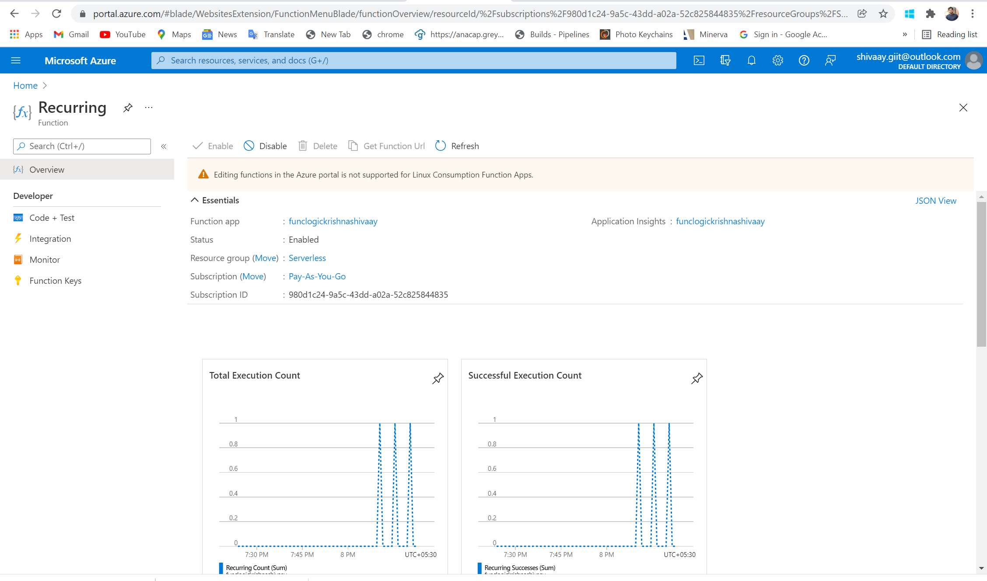

1. On the **Functions** pane, select the existing **echo** function.

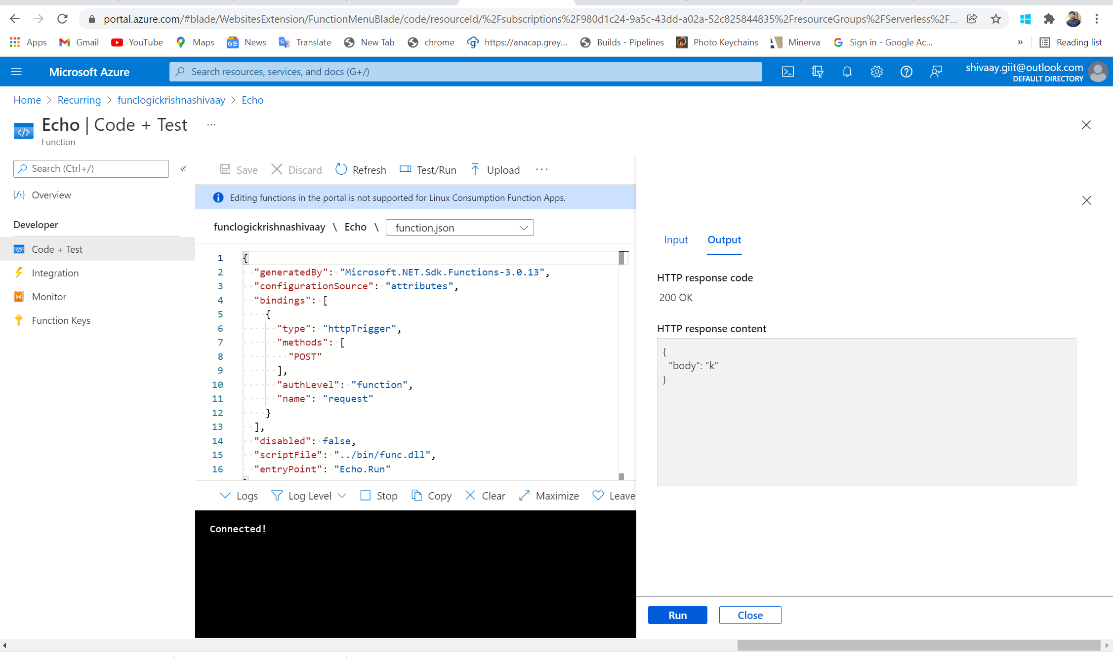

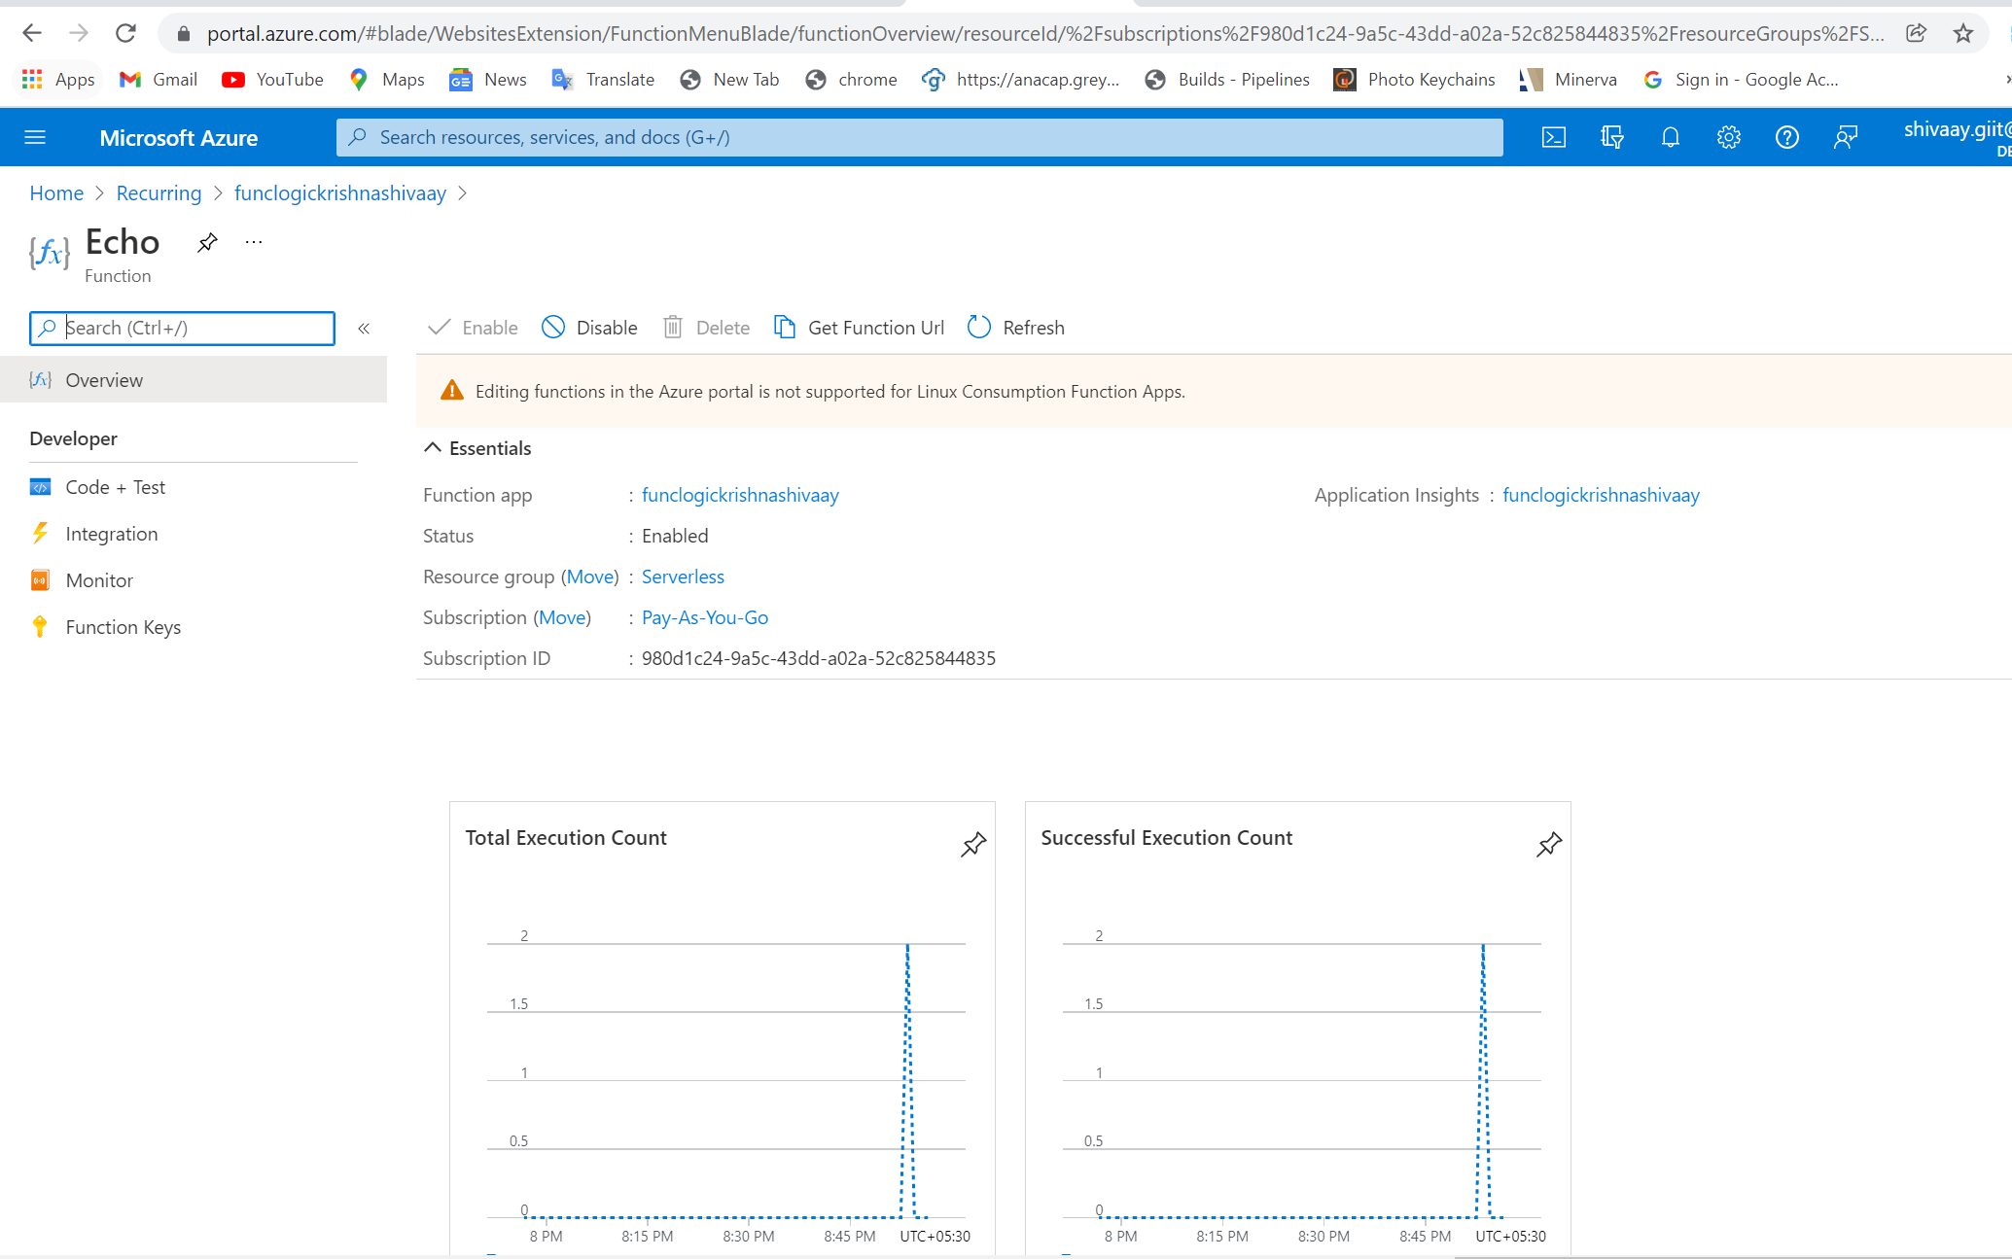

3.On the **Functions** pane, select the existing **GetSettingInfo** function.

1.

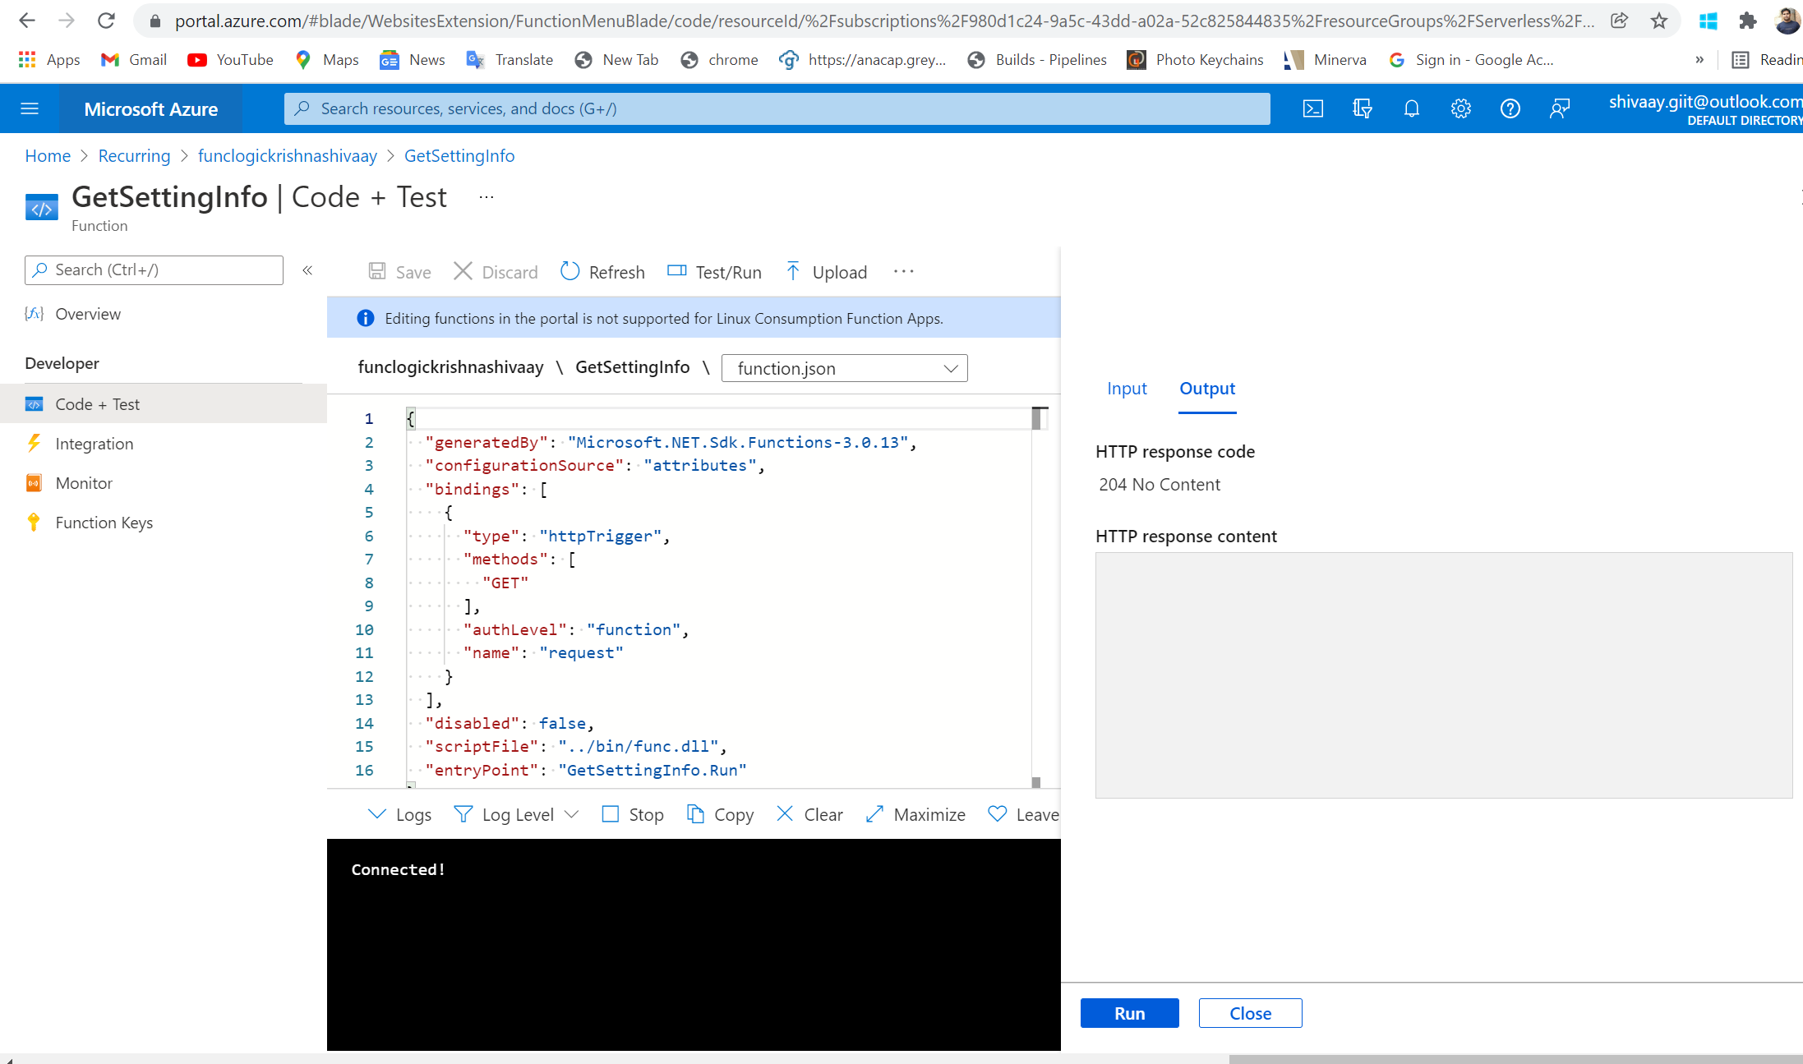

2.

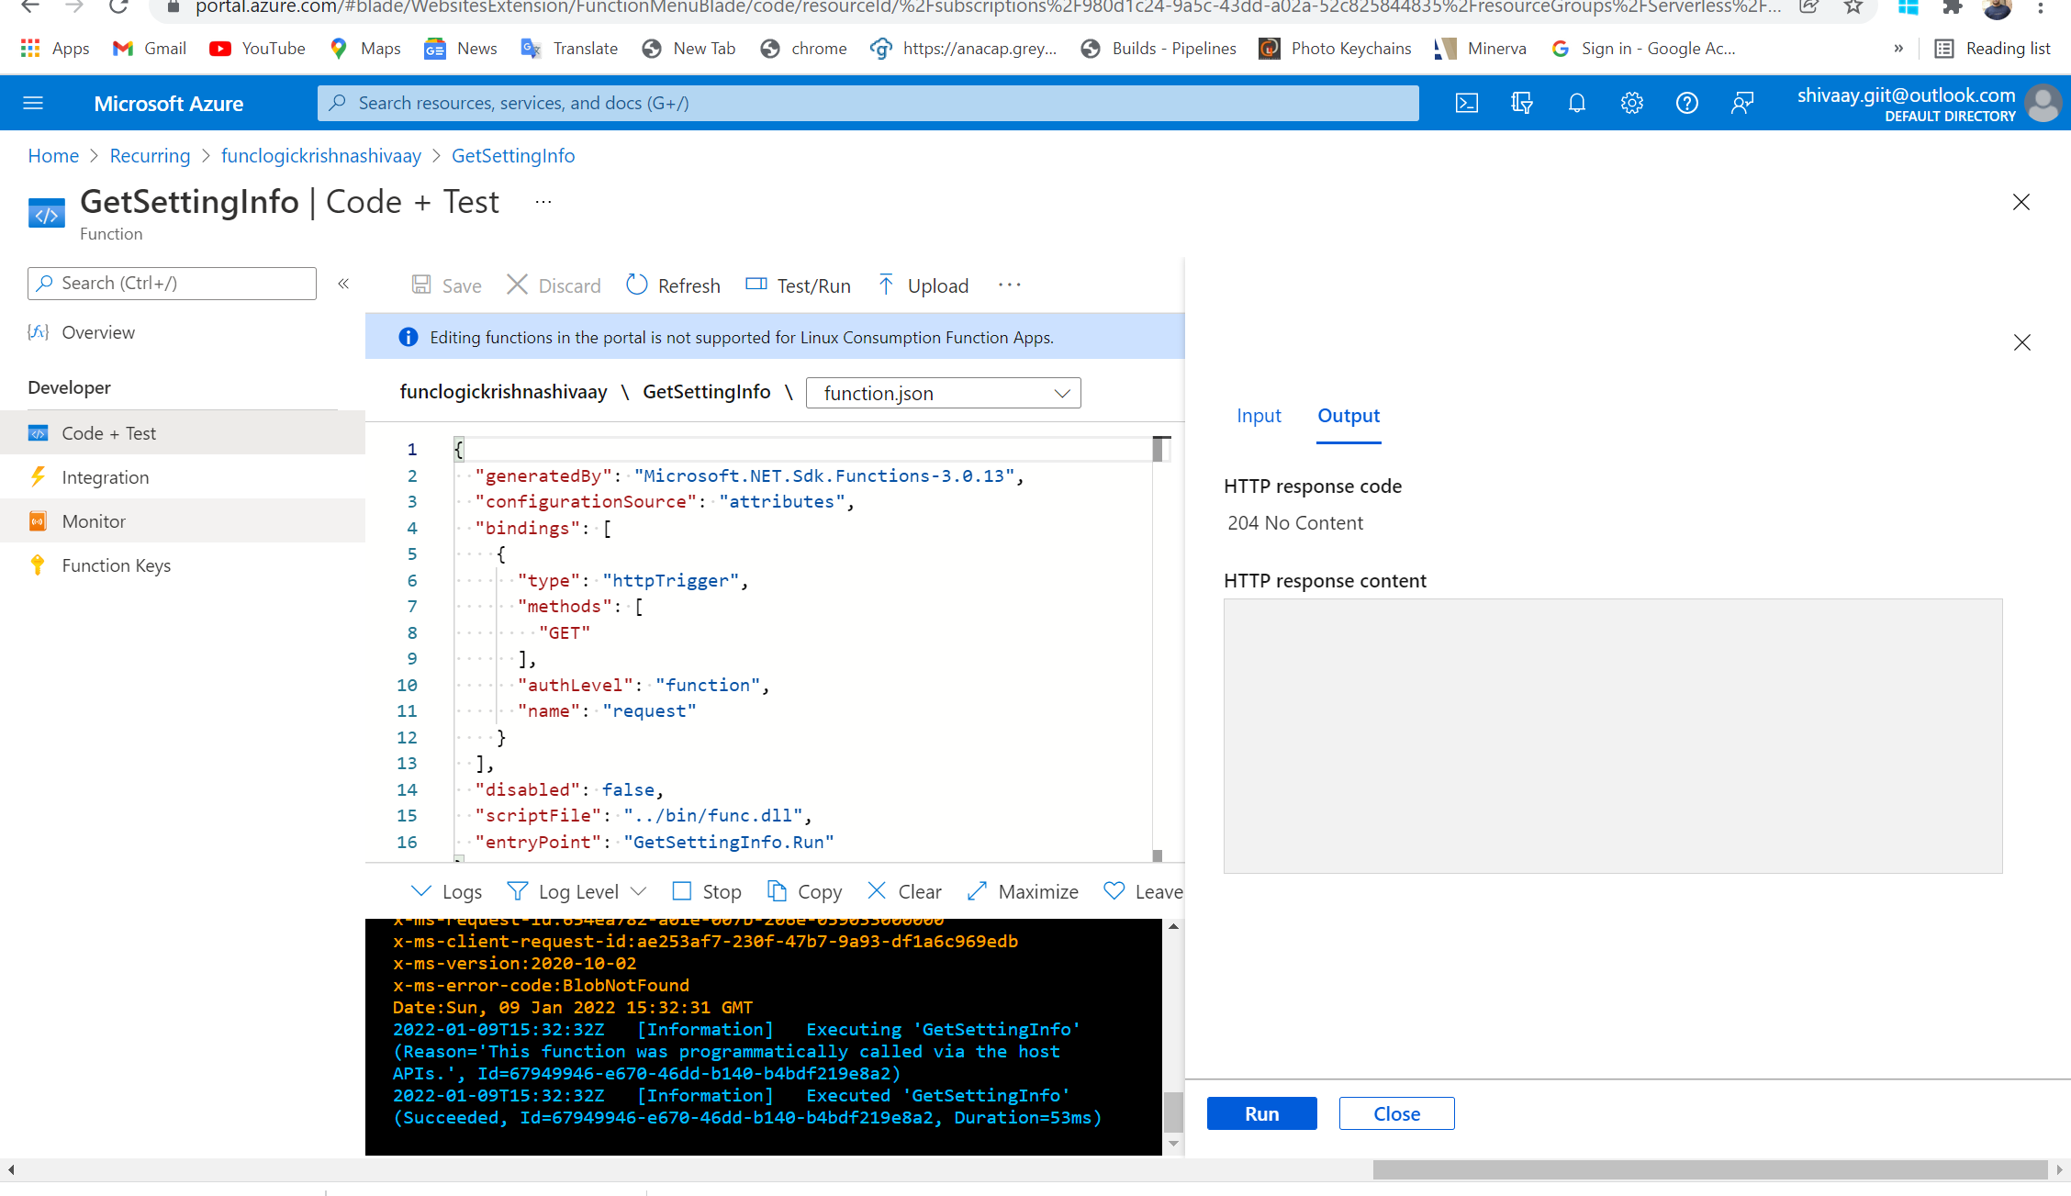

1. Successfully function count dashboard

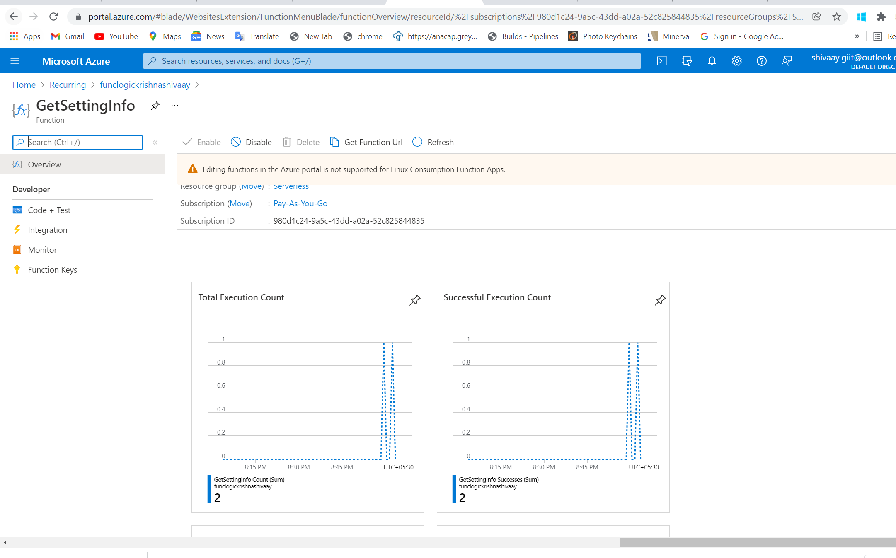

### Exercise 7: Clean up your subscription

#### **1.Open Azure Cloud portal and list resource groups**

#### **2.Delete a resource group**

## az group delete --name Serverless --no-wait --yes